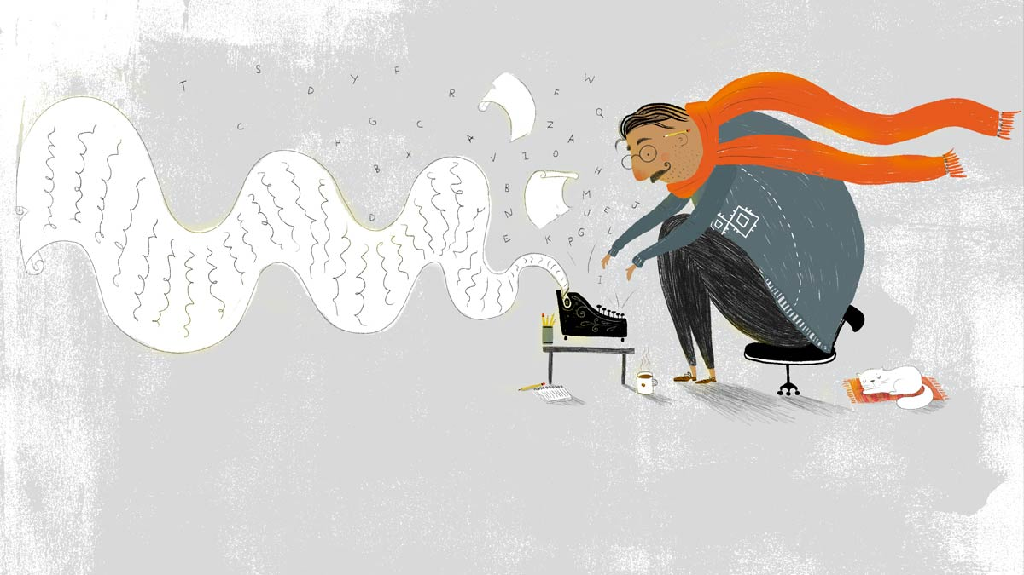
Newsletter: November 2019

Board Members 2018 - 2019
President: Tish Glasson
Vice President: Jason Glasson
Secretary: Leslie Galbraith
Treasurer: Shayne Sawyer
Membership: Morgan Chilson
Newsletter: Brittany Willes
Advisor to the President: Billie-Renee Knight

November Meeting Program
Saturday, November 23, 2019

CHRISTMAS PARTY

Our Christmas party is almost upon us. This year it falls on Saturday, November 23rd. As in
other years, we’ll party in the basement of, First Congregational Church, 1701 S.W.
Collins, Topeka (the corner of 17 th and S.W. Collins.) There is a lift to the basement.

Some of us arrive around 11:00 am to set up. The luncheon begins around 11:30am, and,
once we’ve stuffed ourselves, we commence with the auction.

Now, what to bring? Our party is a potluck luncheon, so we ask that you bring a dish of
your favorite food to share and booze is welcome.

Also, (but not required) bring an unwrapped gift for the auction—something in the $20.00
range, and up, if you feel so inclined.

This year we are including guests. So, if you have a special someone or multiple folks, feel
free to bring them along for the fun. Just note that you may want to bring a large dish for the potluck.

See you there!

Author Fair

Saturday, December 1st the Topeka and Shawnee County Public Library is hosting an author fair. KWI is hosting a table with handouts for folks interested in our group. Anyone wanting to sit with us, chat, or visit with authors, please come along and enjoy.

JANUARY 2020 PROGRAM

Reminder: There is no meeting in December. We will gather again in January for our annual big critique session. We’ll split into groups, read each other’s work, and give in depth
feedback. If you’re planning on attending and bringing work to be critiqued the following guidelines will help to ensure everyone has enough time to have their work read:
- Limit of 10 single-sided pages or 5 double-sided
- double spaced
- new times roman or an easily read font
- font size 12

See you all in January!

October Meeting Minutes
Saturday, October 26, 2019

Not available at time of publishing.

KWI ANNUAL RETREAT 2020

It’s never too soon to be thinking and planning for the KWI annual retreat. Our members had such a positive experience at the Lake Wabaunsee house in Wabaunsee County, KS, that we have booked it again for next year’s retreat. The dates are: Friday through Sunday, April 22nd, 23rd, 24th, 2020.

So mark your calendar if you’re interested in a fun weekend of eating, drinking, hot-tubing, fishing from the jetty (B.Y.O. fishing pole) golf cart racing, horse riding (yee ha) foosball playing, bbq-ing, and the all-important WRITING!

Shayne will happily take your $50.00 non-refundable deposit to guarantee a bed, any time between
now and February 1st 2020.

Financials

October 2019
Beginning Cash Balance $3,902.86
Income $60.00
Expenses $372.48
Ending Cash Balance $3,590.38

Kudos

None

KWI Blog

Are you interested in writing a blog for KWI? Contact Tish ‘Bear’ Glasson by e-mail: bearwmnkwi@gmail.com (She offers bribes for posts).

KWI Meetings

Next Meeting
When: January 25, 2020
Where: TSCPL, Anton Room
Topic: Annual Critique Session

Future Meeting
When: February 22, 2020
Where: TSCPL, Anton Room
Topic: TBA

All Meetings Begin as Follows:
Duration: 9:30am - 2:30pm

Open Writing - 9:30am - 10:00am
Critiquing - 10:00am - 11:30 am

Board Meeting - 11:30am - 12:00pm
Member Meeting - 12:30pm - 1:00 pm
Program Topic - 1:00 pm - 2:30pm

Visit us online at: www.kswritersinc.com, www.kswriters.wordpress.com

December Online Workshops

FREE Mini Retreat
Date: December 2-13, 2019
Presenter: Susan Palmquist. FMI, http://www.oirwa.com/forum/campus/#DEC7.

Writing Short
Date: December 2–13, 2019
Presenter: Jacqui Jacoby. FMI, http://rwaonlinechapter.org/

Regency Electoral Politics and Women’s Participation
Date: December 2–30, 2019
Presenter: Rose Lerner. FMI, Ruchama Burrell, workshop chairperson, wokshops@fthrw.com.

