Board Members  2021-2022  President: Tish Glasson  Vice President: Jason Glasson  Secretary: Billie-Renee Knight  Treasurer: Shayne Huxtable  Membership: Brittany Willes  Newsletter: Connie Beckett  Advisor to the President: Billie-Renee Knight  KWI Blog: Tish Glasson  Interested in writing a blog for KWI? Contact Tish Glasson, bearwmnkwi@gmail.com  Visit us online at: www.kswritersinc.com, www.kswriters.wordpress.com | Kansas Writers, Inc.  August 2021 Newsletter  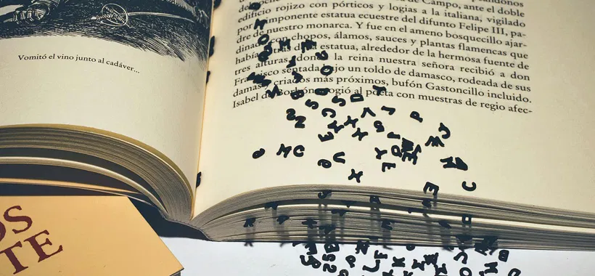  Ponderings and Smackerals:  Greetings Writer Friends,  August marks the start of the “new year” for KWI. Thank you for hanging in with us through the turmoil that was 2020, and I hope you will hitch a ride with us for the next year.  August is also the time for the board to set goals for the year ahead. If there is anything you would like to see this group do/accomplish this year, please let a board member know. And as always, if you have an idea for a program you would like to see, please let me or Jason know.  I hope to see you all at the meeting Saturday, August 28. Don’t forget that due to scheduling conflicts with the Blue Moose, this meeting will be from 8:30-12:30. Back to our regular schedule in September.  I wish you words,  Bear
KWI Meetings  Future Meetings  When: Sept. 25, 2021  Where: Blue Moose  Topic: TBA  Future Meeting  When: Oct. 23, 2021  Where: Blue Moose  Topic: TBA  Meeting Format  Open Writing: 9:30am - 10:00am  Critiquing: 10:00am - 11:30am  Board Meeting: 11:30am - 12:00pm  Member Meeting: 12:30pm - 1:00 pm  Program: 1:00 pm - 2:30pm  Financials  July 2021 uly 2021  Beginning Cash Balance: $3,798.64  Income: $00.00  Expenses: $00.00  Ending Cash Balance: $3,798.64 | August Meeting/Program  We’re changing up a bit this month and will be meeting at The Blue Moose. The address is 3030 SW Wanamaker Rd. Because Blue Moose had a prior scheduling commitment, we will be meeting this month from 8:30 a.m. to 12:30 p.m.  As we’ve been doing for the last several months, there will be no program. Instead, the time will be devoted to critiquing each other’s work. So if you would like feedback on a project, bring up to 5 double-spaced pages.  Hope to see several of you there!  A big Thank You to Angela Johnson for providing the following list of upcoming writing workshops.  SEPTEMBER ONLINE WORKSHOPS  MicroRevisions & Deep POV  Date: September 1–28, 2021  Presenter: Suzanne Johnson. FMI, https://www.rwakissofdeath.org/coffin  New Beginnings and Left Turns  Date: September 1–28, 2021  Presenter: Kathryn Jane. FMI, http://contemporaryromance.org/workshops/  Take Your Character from Flat to Fabulous  Date: September 1–28, 2021  Presenter: Cynthia Owens. FMI, http://contemporaryromance.org/workshops/  Writing the Forensic Psychiatrist  Date: September 1–28, 2021  Presenter: Susan Hatters Friedman, MD. FMI, https://www.rwakissofdeath.org/coffin.  Love Your Voice  Date: September 1-30, 2021  Presenter: Julie Rowe. FMI, https://a2psr.rwa.org/A2PSR/Events/Event_Display.aspx?EventKey=A2PSEP21_2  Using Small Conflicts to Move a Story Along  Date: September 1–30, 2021  Presenter: Mary Marvella. FMI, https://a2psr.rwa.org/A2PSR/Events/Event_Display.aspx?EventKey=A2PSEP21_1  Ground Your Readers from Page One  Date: September 1–31, 2021  Presenter: Katie McCoach. FMI, http://contemporaryromance.org/workshops/  Critiques: How to Give and How to Get (Without the Tears and Frustration) Part 1  Date: September 6–17, 2021  Presenter: Katie McCoach. FMI, https://www.rwakissofdeath.org/coffin.  Anthologies  Date: September 6–27, 2021  FMI, http://www.oirwa.com/forum/campus/  Research for Authors  Date: September 6–27, 2021  FMI, http://www.oirwa.com/forum/campus/  Self-Editing  Date: September 6–27, 2021  FMI, http://www.oirwa.com/forum/campus/  Writing Conflict & Suspense  Date: September 6–27, 2021  FMI, http://www.oirwa.com/forum/campus/  Hearing Voices 101: Creating Distinct Characters  Date: September 6–30, 2021  Presenter: Midnight Voss. FMI, http://www.neorwa.com/online-workshops/upcoming-meetings/  Story Bibles for Novelists  Dates: September 6–30, 2021  Presenter: Joan Bouza Koster (Zara West). FMI, http://www.yosemiteromancewriters.com  Writing a Successful Holiday Romance  Date: September 6–30, 2021  FMI, https://hcrw.rwa.org/HCRW/Events/Event_Display.aspx?EventKey=HCRWSEP21  Let’s Talk About Sex  Date: September 11, 2021, at 1 p.m. ET / 12 p.m. CT / 10 a.m. PT  Presenter: LaQuette. FMI, http://contemporaryromance.org/workshops/  2022 Is Your Year for You and Your Book Business  Date: September 18, 2021, at 1 p.m. ET / 12 p.m. CT / 10 a.m. PT  Presenter: Ainsley St Claire. FMI, http://contemporaryromance.org/workshops/  Kudos  Congratulations to Connie Beckett. She has been invited to do an author signing at Barnes & Nobel on August 28, between 1:00-5:00 p.m. for her novel Kingmaker and the Scribe. Please come by and say hello.  And Last  If you have listened to an interesting podcast, watched a YouTube video, or read a book with helpful writing advice, we would love to share it with our members. Email the information or the link to conniebeckett942@gmail.com

