- Board Members  2021-2022  President: Tish Glasson  Vice President: Jason Glasson  Secretary: Billie-Renee Knight  Treasurer: Shayne Huxtable  Membership: Brittany Willes  Newsletter: Connie Beckett  Advisor to the President: Billie-Renee Knight  KWI Blog: Tish Glasson  Interested in writing a blog for KWI? Contact Tish Glasson, bearwmnkwi@gmail.com  Visit us online at: www.kswritersinc.com, www.kswriters.wordpress.com | Kansas Writers, Inc.  October 2021 Newsletter  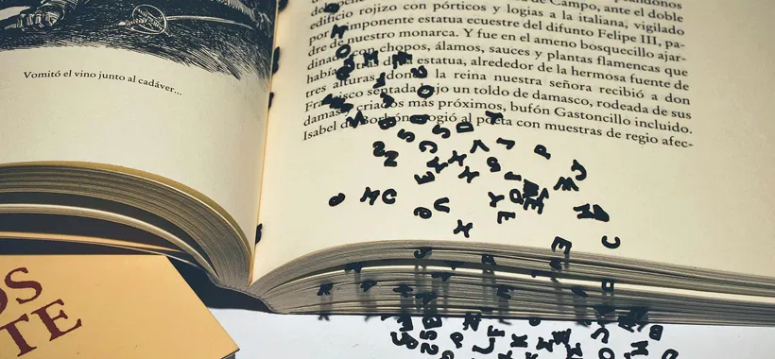  Ponderings and Smackerals:  Can you believe that October is more than half over? This month has simply flown by, November is on the horizon, and brings with it the writing frenzy known as NaNoWriMo or National Novel Writing Month. Every November countless writers all over the world commit to writing 50,000 words in 30 days. It’s insane, it’s exhilarating, and it can be your most productive and creative month of the year if you let it be. There is even a whole community of “WriMos” in Topeka to support you on your journey. If this sounds intriguing to you I invite you to join with your fellow writers and challenge yourself to write a novel in 30 days. For more information check out NaNoWriMo.org.  I wish you words,  Bear
- KWI Meetings  Future Meeting  When: Nov 20, 2021  Where: TBA  Topic: TBA  Future Meeting  When: Jan 22, 2022  Where: TBA  Topic:  Meeting Format  Open Writing: 9:30am - 10:00am  Critiquing: 10:00am - 11:30am  Board Meeting: 11:30am - 12:00pm  Member Meeting: 12:30pm - 1:00 pm  Program: 1:00 pm - 2:30pm  Financials  - KWI Meetings  Future Meeting  When: Nov 20, 2021  Where: TBA  Topic: TBA  Future Meeting  When: Jan 22, 2022  Where: TBA  Topic:  Meeting Format  Critiquing and video: 10:00am  Board Meeting: 11:30am - 12:00pm  Financials  September 2021  Beginning Cash Balance: $3,316.10  Income: $00.00  Expenses: $00.00  Ending Cash Balance  $3,316.10  0 | October Meeting/Program  Because of the difficulty in finding a place to meet this month, the October meeting scheduled for the 23rd has been cancelled.  In November, we will be meeting on the third Saturday of the month (November 20) due to the Thanksgiving holiday. The location of the meeting will be announced later.  We do not meet in December.  October Retreat  KWI is holding a fall retreat this year at Wabaunsee Lake over the weekend of October 29th, 30th and 31st. The address is: 440 East Flint Hills Dr, Alma, KS 66401. Plug that into your maps app and it'll send you to the lake.  If you're coming out just for the day, there's a $20.00 fee to assist with the cost of the entire weekend. For those who spend the entire weekend the cost will be divided equally among us.  Bring your own food, drinks, snacks etc. We'll BBQ Friday and Saturday. Bring a side to share only if you want to.  The hot tub is working, "bathing suits required," she said tongue in cheek.  If you want to RSVP, please let Shayne know at shaynehuxtable@gmail.com  She has several names on the list already.  From the Slush Pile  Brittney Willes and Connie Beckett set up a KWI table in front of the Round Table bookstore again at the October NOTO First Friday Art Walk.  Like in August, they handed out KWI brochures and visited with NOTO attendees. A BIG thank you to the Round Table staff for letting us display there. Small, locally owned bookstores have become a rarity and we encourage members to support them.  With November approaching fast, National Novel Writing Month (NaMoWriMo) is on our minds. If you’re not familiar with it, here’s the scoop from their website.  “National Novel Writing Month began in 1999 as a daunting but straightforward challenge: to write 50,000 words of a novel in thirty days. Now, each year on November 1, hundreds of thousands of people around the world begin to write, determined to end the month with 50,000 words of a brand-new novel. They enter the month as elementary school teachers, mechanics, or stay-at-home parents. They leave novelists.”  I know it sounds daunting, but if you have a story (novel or short) rolling around in your head, this might just motivate you to start. Their website offers tools, resources, and community support. Visit them at http://www.nanowrimo.org to sign up (free but donations accepted) and learn more  The Johnson County Library is holding its online Writers Conference 2021 Thursday, November 7 – Sunday, November 10. KWI member, Margaret Olmes, said, “I’ve worked these conferences in the past as a staff member, and they are an amazing opportunity for all writers no matter where you are in your writing career.”  The 7th annual Writers Conference will kick off on Thursday November 4th, with a discussion on hope and inspiration featuring conference faculty members Alyssa Cole and Michelle Tea. Friday and Saturday will include lectures and workshops on everything from building a DIY writing career, writing through problems in your community, crafting pleasure narratives, and bending genre. Sunday’s sessions will focus on advice for young writers, targeted at grades 4-8. Though we'll be online, we'll feature opportunities to connect like morning coffees and lunch hours with creativity coach Philip Denver and after-hours book discussions with Jessica Conoley; you'll be bumping into old friends while making new ones and leave with new energy and inspiration for your next literary project.  To learn more and sign up for the conference, click on the image below.  Member Shayne Huxtable said, “I just listened to a recorded webinar from B&N nook executives and they talked about a company called, Inkubate, that lets writers know comparative famous authors with whom they have similar writing styles, for the purpose of discovering a readership and marketing. They have a website. I don't know if there's a cost for this, but it seems like a legit tool for writers trying to get published.”  Information on the Injubate.com website shows they:  - Provide sales data about your top matched authors to help you gauge the size of your target audience.  - Teach writers how to communicate with an audience by providing links to top matched authors' reader reviews. See what readers like and don't like about authors you write like and how to use this information to your advantage.  - Show you 'who you write like' and how to target their audience. Published authors whose books have been listed in the NPD Bookscan™ Top 100 list over the last 10 years already have audiences that you can tap too!  November Online Writing Workshops  Writer’s Digest University offers workshops on a wide variety of genres and writing experience. You can learn more at https://www.writersonlineworkshops.com/.  The Writer’s Digest website offers (free) articles on writing fiction, non-fiction, and memoirs as well as articles on getting published, finding inspiration and upcoming competitions. You can find them at https://www.writersdigest.com/.  Kudos  Congratulations to member Romie Chavez. He won the Lulu.com’s 5th Annual Share Your Scare Anthology contest. The submission guidelines required writers to create a piece of flash fiction—Halloween themed and limited to 1,500 words. Winners had their work published in the anthology, along with a free copy of the book and Lulu.com swag. They contacted all the chosen authors and made an official announcement on their Facebook page on October 8th. For details and to order your copy, click on the image below.  Romie said, “I’m truly humbled and honored to be chosen. As an author, it’s always exciting to get your work published. The decision to enter the contest was nerve-racking. It forced me to go out of my comfort zone and try something new. I learned a lot about editing and getting to the heart of the story. I am so thankful for my KWI colleagues! The feedback and encouragement helped tremendously.”  