- Board Members  2021-2022  President: Tish Glasson  Vice President: Jason Glasson  Secretary: Billie-Renee Knight  Treasurer: Shayne Huxtable  Membership: Brittany Willes  Newsletter: Connie Beckett  Advisor to the President: Billie-Renee Knight  KWI Blog: Tish Glasson  Interested in writing a blog for KWI? Contact Tish Glasson, bearwmnkwi@gmail.com  Visit us online at: www.kswritersinc.com, www.kswriters.wordpress.com | Kansas Writers, Inc.  January 2022 Newsletter  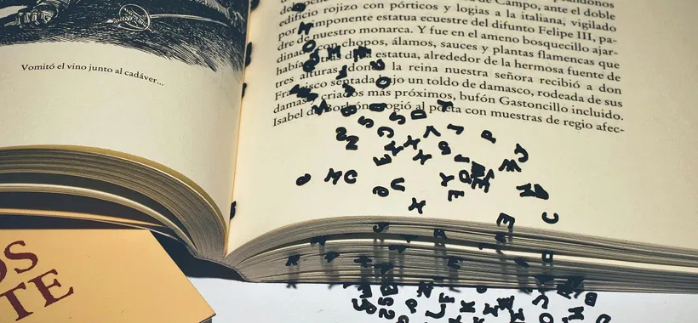  Ponderings and Smackerals:  Greetings, writer friends,  Ah, January. New year, new you. Resolutions. All the baggage the new year brings with it. How many of you made resolutions this year? How many have broken them already? Allow me to out myself. One of my resolutions was to have this bit of wisdom prepared before Connie had to ask me for it. Spoiler alert—I didn’t. It’s like I went to bed on December 31st thinking I would wake up an entirely different person on January 1st. More spoilers—I didn’t.  Wait. I know I had a point when I started but I seem to have misplaced it. It’s around here somewhere but I can’t seem to find it. I’m sure it was all about setting reasonable goals and being kind to yourself while pursuing them. Yeah, that’s it. Let’s go with that.  Hope to see you all Saturday! As always, I wish you words.  Bear
- KWI Meetings  Future Meetings  When: January 22, 2020  Where: Topeka/Shawnee County Library  Topic: TBA  Future Meetings  When: Feb. 26, 2022  Where: TBA  Topic: TBA  Meeting Format  Program: 10:00am  Board Meeting: 11:00  Critique: 12:00pm  Financials  November 2021  Beginning Cash Balance: $2,940.28  Income: $601.85  Expenses: $40.00  Ending Cash Balance  $3,592.13  December 2021  Beginning Cash Balance: $3,502.13  Income: $0.00  Expenses: $0.00  Ending Cash Balance  $3,502.13 | January Meeting/Program  From the Slush Pile  REMINDER: There is still time. Do you have a historical romance novella manuscript looking for a home? If so, Dragonblade Publishing is promoting a contest for historical romance fiction taking place from World War II and earlier. They offer cash prizes as well as the potential to be published in a Dragonblade collection. The submission cut-off is February 1, 2022. Details can be found on their website at  https://www.dragonbladepublishing.com/  New Year, new meeting format. Starting this month, we will begin with a 10 a.m. program. The meeting will start at 11 a.m. Writing critiques will be at noon for those who wish to participate. The January program is How to Pitch your Book to Agents, Publishers, and Readers. The link is: https://podcasts.apple.com/gb/podcast/how-to-pitch-your-book-to-agents-publishers-readers/id309426367?i=1000463117884  There are many genre-based organizations that offer online workshops and educational articles. It’s a good way to distract us from a cold, dreary January. Here are a few. Let us know if you have others.  Romance Writers of America www.rwa.org  Historical Writers’ Association www.historicalwriters.org  Science Fiction and Fantasy Writers of America www.sfwa.org  Sisters in Crime www.sistersincrime.org  Society of Children’s Book Writers and Illustrators www.scbwi.org  National Association of Memoir Writers www.namw.org  February Online Writing Workshops  A big thank you to Angela Johnson for providing information on upcoming workshops for a variety of topics.  50 Rude Questions to Get to Know Your Characters  Date: Feb 1-25, 2022  Presenter: Peter Andrews, FMI, https://rwaonlinechapter.org/workshops-3/  Deep Third  Date: February 1–25, 2022  Presenter: Linnea Sinclair, FMI, http://www.oirwa.com/forum/campus/#FEB.  Dig Deep - Researching Your Novel  Date: February 1–25, 2022  Presenter: Cynthia Owens, FMI, http://www.oirwa.com/forum/campus/#FEB.  Making Sensory Details Make Sense  Date: February 1–25, 2022  Presenter: Mary Marvella, FMI, http://www.oirwa.com/forum/campus/#FEB.  Marketing & Branding  Date: February 1–25, 2022  Presenter: Cassandra Carr, FMI, http://www.oirwa.com/forum/campus/#FEB.  The Romantic Suspense  Date: February 1–25, 2022  Presenter: Beth Henderson, FMI, http://www.oirwa.com/forum/campus/#FEB.  Dastardly Digital Deeds (How Cybersecurity and Computer Forensics work, to Defend Against Cybercrime)  Date: February 1–28, 2022  Presenter: Kim Lambert with Tomasz Ciole, FMI, RWAKissOfDeath.org/workshops  Twitter for Authors  Date: February 1–28, 2022 (one month)  Presenter: Cassandra Carr, FMI, https://agedtoperfectionromancewriters.com/workshops/  Take Your Characters from Flat to Fabulous: Creating Characters Your Readers Will Love  Date: February 5, 2022 (90-minute virtual class ;7:00 a.m. Pacific, 9:00 a.m. Central, 10:00 a.m. Eastern)  Presenter: Cynthia Owens, FMI, RWAKissOfDeath.org/workshops  More Than Setting: World-Building  Date: February 7–18, 2022  Presenter: Laurie Schnebly, FMI, RWAKissOfDeath.org/workshops  Instagram for Authors  Date: February 26, 2022, 9 a.m. PT  Presenter: Stephanie J. Scott, FMI, https://agedtoperfectionromancewriters.com/workshops/  CLASS: HOW TO WRITE A NOVEL (HTWAN) by Holly Lisle  I believe as writers, we can never stop learning and improving our craft.  Awhile back I came across a wonderful course by seasoned writer Holly Lisle titled - HOW TO WRITE A NOVEL (HTWAN).  I had already taken another course about "revising" a novel from Holly. I was very impressed with her vast knowledge base and teaching style. So even though I had already published two novels through a traditional New York publishing house, I was open to exploring her approach to the "writing" process.  Holly's teaching format for HTWAN was unique, in that, as we were completing each weekly lesson, we were in fact, writing the first draft of our novel. For me this is Book Two of my new series.  With the very first lesson I began flushing out AND fleshing out characters, plots, and conflicts which enriched my story by making it more complex, surprising and action packed.  In almost every lesson I learned something new that I could incorporate into my storytelling and enhance it dramatically. So taking Holly's HTWAN course was one of the best decisions I've ever made regarding my writing career. And I can honestly say that I am more excited, inspired, and confident in my writing than ever before.  By Angela Johnson  If you are interested to learn more about this course, please contact Angela at angelajohnsonauthor@gmaiil.com ASAP. The class is currently half-price but not for long.  Kudos  If you have published a book, received a writing award, appeared on a Podcast, or other such reason to celebrate a success, please let Connie know at conniebeckett942@gmail.com. We would love to feature you in an upcoming newsletter.

